CDS End to End Sequence Diagrams

Abstract

|  |
| --- |
| This document defines the end to end message flows for a variety of scenarios. This document has been created mid-way through an agile process and is therefore subject to change. Where the programme has not yet elaborated a requirement in a specific area, this has been identified within the document. |

**Origin/Author:** Ben Wallis

**Date Issued:** 09.04.20

**Status:** Baselined

Prepared by: HMRC (CDIO (C&IT) – CDS)

**Contents**

1. Introduction 4

1.1 Scope 4

1.2 References 4

1.3 Key Updates 4

2. Scenarios 5

2.1 Scenarios Described 5

2.1.1 CSP Specific Import Transactions 5

2.1.2 Key Identifiers for Messages 6

2.2 Import Message Flows 7

2.2.1 Submitting a Pre-lodged Declaration (Imports) 8

2.2.2 Arriving a Declaration (Imports) 13

2.2.3 Submitting an Arrived Declaration (Imports) 21

2.2.4 Submitting a Supplementary Declaration (with CSP) 28

2.2.5 Submitting a Pre-lodged Declaration (NILP) 30

2.2.6 Arriving a Declaration (NILP) 33

2.2.7 Submitting a Supplementary Declaration (no CSP) 38

2.3 Export Message Flows 41

2.3.1 Submitting a Pre-lodged Declaration (Exports) 41

2.3.2 Submitting an Arrived Declaration (Exports) 44

2.3.3 Submitting a Supplementary Declaration (Exports) 47

2.3.4 Export Arrival 49

2.3.5 Export Anticipated Arrival 57

2.3.6 Export Departure 60

2.3.7 Consolidation Association 63

2.3.8 Consolidation Disassociation 65

2.3.9 Consolidation Shut 67

2.3.10 Re-arrival of a UCR 69

2.3.11 Re-processing of a Declaration 73

2.4 Additional Message & Miscellaneous Flows 75

2.4.1 Declaration Amendment 75

2.4.2 Declaration Invalidation 79

3. Appendices 82

3.1 Declaration Types 82

4. Document Control 83

# Introduction

## Scope

This document defines the end to end sequencing for the submission of a declaration, an amendment, an invalidation, as well as the export inventory linking transactions. All processes are largely triggered from the receipt of a declaration or an additional message in the WCO format.

Where XML is mentioned in this document, for declaration messages it refers to the new UCC/WCO declaration standard to be used by CDS. Note that external CDS interfaces follow the WCO format, but validation will follow the UCC/EUCDM standard. For inventory linking messages, it refers to the updated XML standard which replaces the current EDIFACT standard used for CHIEF.

This document does not cover connectivity, technical acknowledgements or the requirements on how to populate the header record, this should be covered in the API specification [1].

## References

|  |  |  |  |  |
| --- | --- | --- | --- | --- |
| **Doc Ref** | **ID** | **Document Title** | **Version** | **Location** |
| CDS 03 | 1 | Customs Declaration API | V1.0 | Developer Hub: <https://developer.service.hmrc.gov.uk/api-documentation/docs/api/service/customs-declarations/1.0> |

## Key Updates

The table below outlines the updates made to the document since the last version issued.

|  |  |
| --- | --- |
| **Section** | **Update** |
| 2.3.1, 2.3.2, 2.3.3 | Added message flows for Exports declarations. |
| 2.2.2, 2.2.3, 2.2.6 | Added DMSALV notification. Corrected suggestion that DMSDOC and DMSCTL are sequential. Detailed scenarios where DMSROG, DMSCLE and DMSCPI are sent. Added note to show where the process loops back to in the cases of finalising measures or quota allocation. |
| 2.2.1, 2.2.2, 2.2.3 | Removed mention of EMSV0001 in inventory linking mismatch. Moved position of DMSREJ for technical rejection to clarify when it is sent. |
| 2.3.4, 2.3.5, 2.3.6 | Added expected SOE codes for EMR and ERS messages |

# Scenarios

## Scenarios Described

For imports, the following scenarios have been covered:

* Submitting a pre-lodged declaration through a CSP into CDS, where that declaration needs to be inventory linked.
* The flow following the receipt of the goods arrival message from a CSP. This flow can be considered a continuation of the above flow, as the goods arrival message is submitted in reference to a pre-lodged declaration
* Submitting an arrived declaration through a CSP into CDS, where that declaration needs to be inventory linked.
* Submitting a supplementary declaration into CDS.
* Submitting a pre-lodged declaration into CDS, where the declaration does not need to be inventory linked.
* Submitting a goods arrival message into CDS, where the declaration does not need to be inventory linked.
* Submitting a supplementary declaration, where no CSP is involved.

For Exports

* Submitting a pre-lodged declaration through a CSP into CDS, analogous to the Imports scenario
* Submitting an arrived declaration through a CSP into CDS
* Submitting a supplementary declaration into CDS
* Submitting an export arrival message to CDS
* Submitting an anticipated arrival message to CDS
* Submitting a full departure or inland departure to CDS
* Submitting a consolidation request to either associate and disassociate a UCR into or from a MUCR.
* Shutting a consolidation

For Additional Messages

* Requesting to invalidate a declaration
* Requesting to amend a declaration

### CSP Specific Import Transactions

In the below sequence diagrams, the majority show the CSP as the ‘submitter’ of the declaration. As the submitter, they will be the first system to receive any response from CDS. The majority will be primarily of interest to the declarant. There are however, a series of CSP specific transactions which should only be received or sent by the CSP system. These are:

* inventoryLinkingImportValidateMovementRequest
* inventoryLinkingImportValidateMovementResponse
* inventoryLinkingImportDeclarationStatusNotification
* inventoryLinkingImportArriveGoods

Every other response from CDS, the DMSxxx notifications, will be routed primarily to the submitter of the declaration. It is the responsibility of the submitter to then route the notifications to the declarant if appropriate. Where a CSP is not present, movement validation and declaration status messages are not relevant. The ‘NILP’ (Non-Inventory Linked Port) sequence diagrams show the interactions where a CSP is not present.

### Key Identifiers for Messages

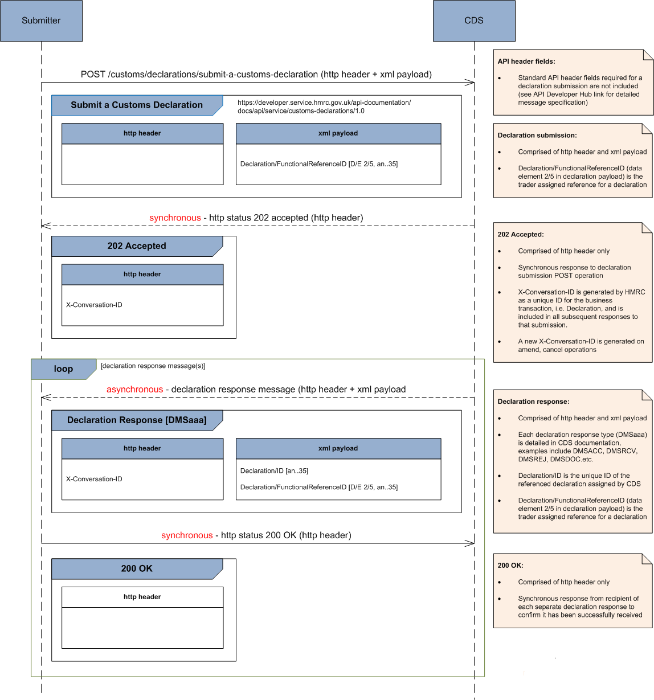

## Import Message Flows

The below message flows describe the interactions between the main components as the declaration goes through its lifecycle. The trader notifications are shown as pushes out to the original submitter, but it is possible to pull these notifications as well (endpoint listed against the operation). Full details of the pull services are within the API documentation. Frontier declaration notifications are yet to be elaborated fully, but it is unlikely they can be consolidated in a similar way due to the DMSTAX notification being utilised as a payment instruction notification.

### Submitting a Pre-lodged Declaration (Imports)



| **ID** | **Operation (endpoint)** | **Description** |
| --- | --- | --- |
| 1a | submitDeclaration  (customs/declarations/submit-declaration) | Submission of the advance/pre-lodged declaration. This could be the full declaration (Type D), the simplified version (Type E or F), or a C21 (Type K) |
| 1b |
| 2 | HTTP error response | Standard error response where the schema does not pass validation at the MDTP level. The mechanism of this error should be defined in the API Schema documentation. It is not shown here, but the CSP may pass the error back to the declarant depending on the error. |
| 3a | notifyTrader (DMSREJ)  (multiple endpoints using root /notifications) | Operation to notify the submitter that the declaration has failed validation and is rejected. This is an end-state and no further action can be taken on the declaration, nor any further processing within CDS. A new declaration will need to be submitted if the intention is to still import the same goods. |
| 3b |
| 4 | inventoryLinkingImportDeclarationStatusNotification  (multiple endpoints using root /notifications) | When an inventory-linked pre-lodged declaration is rejected, a CSP notification will be sent.  **ICS/ROE Values:** the status of the declaration (ICS) will be 5 (Declaration Rejected) |
| 5 | inventoryLinkingImportValidateMovementRequest  (multiple endpoints using root /notifications) | This service will be used to request a CSP to check whether they can identify the ICR on the declaration, and that the number of packages matches against the inventory record. There is no declarant involvement in this interaction.  **ICS/ROE Values:** the status of the declaration (ICS) will be 1 (Declaration Validation), and the ROE will be 0 (meaning 'to be determined' as the declaration has not been risked yet). |
| 6 | inventoryLinkingImportValidateMovementResponse  (customs/inventory-linking-imports/movement-validation) | The response back to the CDS service which comprises of the schema as defined. The key value will be the IRC which specifies whether the match has been successful. An unsuccessful match is the trigger for the re-validation loop as specified in the Inventory Linking Import specification. |
| 7a | notifyTrader (DMSRCV)  (multiple endpoints using root /notifications) | Part of an alternative flow where the Inventory Return Code has returned a mismatch. This will cause the DMSRCV notification to be sent back notifying the trader of the inventory mis-match. The notification will contain a RevalidationRequiringValidationResult to differentiate this from a standard registration notification. |
| 7b |
| 8a | submitAmendment  (customs/declarations/amendment-request) | In the case of a non-match, an amendment may be needed to rectify the declaration, rather than the consignment record on the CSP system. The declaration service allows an actor to submit an amendment into the CDS service, which will cause a re-validation of the declaration, including the inventory reference and total packages.  **ICS / ROE Values** (on re-validation):  The process will then return to step 3. When the revalidation occurs with CSPs the message will contain an ICS of 7 (Declaration Correction Validation) and ROE of 0 (No risk performed yet). |
| 8b |
| 9a | notifyTrader (DMSRCV)  (multiple endpoints using root /notifications) | The submitter is notified of a change in status of the declaration. Following successful inventory linking and validation, this provides the positive response back to the trader that the pre-lodged declaration has been registered. A timer now starts for the goods arrival message to be submitted. If the arrival is not received within 30 days, the declaration is invalidated.  Any credibility checks identified during validation will be passed back here as separate validationResults. |
| 9b |
| 10 | inventoryLinkingImportDeclarationStatusNotification  (multiple endpoints using root /notifications) | Following validation and a positive linking, the declaration is risked. This service will be called to notify the CSP of the potential route of the declaration.  **ICS/ROE Values:**The declaration status (ICS) will be 14 (Declaration Risked), and ROE will be based on the control type |
| 11a | notifyTrader (DMSDOC)  (multiple endpoints using root /notifications) | Operation to notify the submitter of the declaration that a documentary control is required. As this declaration is a pre-lodged declaration then there will be no notification to the trader of any potential physical control. |
| 11b |
| 12 | uploadDocument  (customs/declarations/file-upload) | Following the receipt of the DMSDOC notification, the documentation can be uploaded to the CDS service. |
| 13 | inventoryLinkingImportDeclarationStatusNotification  (multiple endpoints using root /notifications) | If the declaration is not arrived within 30 days of the pre-lodged declaration being registered, the declaration will be rejected.  **ICS/ROE Values:**  The notification will contain an ICS of '11' (Declaration Rejection at Goods Arrival). |
| 14a | notifyTrader (DMSREJ)  (multiple endpoints using root /notifications) | The specific trader notification regarding the rejection of the declaration following the declaration not being arrived. It will contain a specific error code to indicate the reason for rejection. |
| 14b |

### Arriving a Declaration (Imports)





| **ID** | **Operation (endpoint)** | **Description** |
| --- | --- | --- |
| 1 | inventoryLinkingImportArriveGoods  (customs/inventory-linking-imports/arrival-notifications) | Notification from the CSP that the declaration should now be arrived. The primary key for this message will be the MRN (Entry Number). If transportNationality is included in the arrival message then this will be treated as an amendment to the declaration. |
| 2a | notifyTrader (DMSREJ)  (multiple endpoints using root /notifications) | If the arrival message fails validation, then CDS will send a DMSREJ notification to inform the declaration submitter of the error. This will be routed through the CSP. |
| 2b |
| 3a | notifyTrader (DMSRCV)  (multiple endpoints using root /notifications) | If the arrival message passes validation, then CDS will send a DMSRCV notification to inform the declaration submitter of the registration of the additional message. This will be routed through the CSP. |
| 3b |
| 4 | inventoryLinkingImportValidateMovementRequest  (multiple endpoints using root /notifications) | During the declaration re-validation the linking is re-checked.  **ICS/ROE Values:**The request will have an ICS value of '1' (validation) and an ROE value of '0' (control yet to be performed). |
| 5 | inventoryLinkingImportValidateMovementResponse  (customs/inventory-linking-imports/movement-validation) | The response back to the CDS service which comprises of the schema as defined. The key value will be the IRC which specifies whether the match has been successful. An unsuccessful match is the trigger for the re-validation loop as specified in the Inventory Linking Import specification. |
| 6a | notifyTrader (DMSRCV)  (multiple endpoints using root /notifications) | Trader notification to request the individual takes action to correct the declaration in the case of a mis-match between the inventory. Note that this is sent after the first linking failure, the system does not wait for the preceding loop to complete as it could be that the CSP system is updated instead. |
| 6b |
| 7a | submitAmendment  (customs/declarations/amendment-request) | If in the case of a non-match, an amendment may be needed to rectify the declaration, rather than the CSP system. The declaration service allows an actor to submit an amendent into the DMS system, which will cause a re-validation of the inventory reference and total packages. This will cause the process to re-validate with the CSP (from step 4).  **ICS / ROE Values** (on re-validation):  When the revalidation occurs with CSPs the message will contain an ICS of 7 (Declaration Correction Validation) and ROE of 0 (No risk performed yet). |
| 7b |
| 8 | inventoryLinkingImportDeclarationStatusNotification  (multiple endpoints using root /notifications) | If the declaration fails re-validation after the goods presentation notification, the declaration could be rejected. This could be for a number of reasons, for example, reference data changes, Tariff data updates, business rule config etc. The trader will be required to submit a new declaration conforming to the new data validation.  **ICS/ROE Values:**  The notification will contain an ICS of '11' (Declaration Rejection at Goods Arrival) and ROE of '0' (no control yet). |
| 9a | notifyTrader (DMSREJ)  (multiple endpoints using root /notifications) | The specific trader notification regarding the rejection of the declaration at re-processing. It will contain the specific validation errors that caused the rejection. There is no ability to amend a re-processing error. |
| 9b |
| 10a | notifyTrader (DMSACC)  (multiple endpoints using root /notifications) | The specific trader notification regarding the legal acceptance of the declaration. This effectively sets the tax point.  Any credibility checks identified during validation will be passed back here as separate validationResults. |
| 10b |
| 11 | inventoryLinkingImportDeclarationStatusNotification  (multiple endpoints using root /notifications) | Following validation and a positive linking, the declaration is risked. This service will be called to notify the CSP of the route confirmation.  **ICS/ROE Values:**  The declaration status (ICS) will be 14 (Declaration Risked), and ROE will be based on the control type. |
| 12a | notifyTrader (DMSDOC)  (multiple endpoints using root /notifications) | Operation to notify the submitter of the identification of a documentary control. This is used to notify the trader of the required control, but also as a request to upload specific documentation. |
| 12b |
| 13 | uploadDocument  (customs/declarations/file-upload) | Following the receipt of the DMSDOC notification, the documentation can be uploaded to the CDS service. |
| 14a | notifyTrader (DMSCTL)  (multiple endpoints using root /notifications) | Potential notification to inform the trader of physical control to be performed against their declaration. |
| 14b |
| 15a | notifyTrader (DMSALV)  (multiple endpoints using root /notifications) | If the declaration was identified as requiring a decision from ALVS (Defra) and the decision was to not release the goods, this message informs the trader of that decision. |
| 15b |
| 16a | notifyTrader (DMSTAX)  (multiple endpoints using root /notifications) | Trader notification providing the debt amounts that have been reserved against their deferment account. This notification can also be used as a prompt for an immediate payment (which will also include a specific payment reference to use). Where the declaration type is simplified, no debt may be liable, depending on the CPC. |
| 16b |
| 17 | inventoryLinkingImportDeclarationStatusNotification  (multiple endpoints using root /notifications) | If there is an issue reserving an amount of money against an account-based method of payment (i.e. deferment account, cash account, or guarantee account), declaration processing will stop while CDS awaiting either a pay down of the debt, or an update to the guarantee. This message is to inform CSPs of the break in the process.  **ICS/ROE Values:**  The message will contain an ICS of '17' (Accounting Failure / Insufficient Guarantees). |
| 18a | notifyTrader (DMSCPI)  (multiple endpoints using root /notifications) | The trader notification regarding the need to take action against a specific account ID and informing the submitter about the amount to be paid up. A DMSCPI will only be sent in the case of insufficient balance of a guarantee account or cash deposit. |
| 18b |
| 19a | notifyTrader (DMSCPR)  (multiple endpoints using root /notifications) | Where action has not been taken on a specific account, 24 hours after the DMSCPI is issued, the trader is provided a reminder. Once the reminder has been sent out, and still no action has been taken, further reminders are issued every 24 hours. If no action is taken after 31 days, then a task will be raised to either manually chase the trader, or invalidate the declaration. |
| 19b |
| 20a | notifyTrader (DMSCPR)  (multiple endpoints using root /notifications) | Where action has not been taken to cover an immediate payment, 24 hours after the DMSTAX is issued, the trader is provided a reminder. Once the reminder has been sent out, and still no action has been taken, further reminders are issued every 24 hours. If no action is taken after 31 days, then a task will be raised to either manually chase the trader, or invalidate the declaration. |
| 20b |
| 21 | inventoryLinkingImportDeclarationStatusNotification  (multiple endpoints using root /notifications) | The declaration clearance message will notify the CSPs that the goods can be released.  **ICS/ROE Values:**  The status (ICS) will either be 3 (Declaration Clearance), or 2 (Declaration Release). The ROE will remain as previously calculated. |
| 22a | notifyTrader (DMSRES)  (multiple endpoints using root /notifications) | When an amendment is made on the declaration, then CDS will send out the DMSRES notification describing the amended data elements. |
| 22b |
| 23a | notifyTrader (DMSROG)  (multiple endpoints using root /notifications) | Where the declaration status allows for the goods to be released, but there are still elements that need finalising on the declaration, CDS will inform the trader of ‘release of goods’.  This scenario may occur:   * If the duties calculated are provisional * If there is a non-blocking documentary control open on the declaration * If the declaration type is simplified   Once the declaration has been finalised the clearance notification will be sent. |
| 23b |
| 24a | notifyTrader (DMSRES)  (multiple endpoints using root /notifications) | When an amendment is made on the declaration, then CDS will send out the DMSRES notification describing the amended data elements. |
| 24b |
| 25a | notifyTrader (DMSCLE)  (multiple endpoints using root /notifications) | Following the declaration process, if the control and the debt is finalised the declaration can be cleared. |
| 25b |

### Submitting an Arrived Declaration (Imports)





| **ID** | **Operation (endpoint)** | **Description** |
| --- | --- | --- |
| 1a | submitDeclaration  (customs/declarations/submit-declaration) | Submission of an arrived declaration. This could be the full declaration (Type A), the simplified version (Type B or C), or a C21 (Type J). |
| 1b |
| 2 | inventoryLinkingImportValidateMovementRequest  (multiple endpoints using root /notifications) | During the declaration re-validation the linking is re-checked.  **ICS/ROE Values:**The request will have an ICS value of '1' (validation) and an ROE value of '0' (control yet to be performed). |
| 3 | inventoryLinkingImportValidateMovementResponse  (customs/inventory-linking-imports/movement-validation) | The response back to the CDS service which comprises of the schema as defined. The key value will be the IRC which specifies whether the match has been successful. An unsuccessful match is the trigger for the re-validation loop as specified in the Inventory Linking Import specification. |
| 4a | notifyTrader (DMSRCV)  (multiple endpoints using root /notifications) | Trader notification to request the individual takes action to correct the declaration in the case of a mis-match between the inventory. Note that this is sent after the first linking failure, the system does not wait for the preceding loop to complete as it could be that the CSP system is updated instead. |
| 4b |
| 5a | submitAmendment  (customs/declarations/amendment-request) | If in the case of a non-match, an amendment may be needed to rectify the declaration, rather than the CSP system. The declaration service allows an actor to submit an amendent into the DMS system, which will cause a re-validation of the inventory reference and total packages. This will cause the process to re-validate with the CSP (from step 4).  **ICS / ROE Values** (on re-validation):  When the revalidation occurs with CSPs the message will contain an ICS of 7 (Declaration Correction Validation) and ROE of 0 (No risk performed yet). |
| 5b |
| 6 | inventoryLinkingImportDeclarationStatusNotification  (multiple endpoints using root /notifications) | If the declaration fails validation, the declaration is rejected. The CSP is notified as the linking will have already taken place.  **ICS/ROE Values:**  The notification will contain an ICS of '5' (Declaration Rejection) and ROE of '0' (no control yet). |
| 7a | notifyTrader (DMSREJ)  (multiple endpoints using root /notifications) | The specific trader notification regarding the rejection of the declaration. It will contain the specific validation errors that caused the rejection. |
| 7b |
| 8a | notifyTrader (DMSACC)  (multiple endpoints using root /notifications) | The specific trader notification regarding the legal acceptance of the declaration. This effectively sets the tax point.  Any credibility checks identified during validation will be passed back here as separate validationResults. |
| 8b |
| 9 | inventoryLinkingImportDeclarationStatusNotification  (multiple endpoints using root /notifications) | Following validation and a positive linking, the declaration is risked. This service will be called to notify the CSP of the route confirmation.  **ICS/ROE Values:**  The declaration status (ICS) will be 14 (Declaration Risked), and ROE will be based on the control type. |
| 10a | notifyTrader (DMSDOC)  (multiple endpoints using root /notifications) | Operation to notify the submitter of the identification of a documentary control. This is used to notify the trader of the required control, but also as a request to upload specific documentation. |
| 10b |
| 11 | uploadDocument  (customs/declarations/file-upload) | Following the receipt of the DMSDOC notification, the documentation can be uploaded to the CDS service. |
| 12a | notifyTrader (DMSCTL)  (multiple endpoints using root /notifications) | Potential notification to inform the trader of physical control to be performed against their declaration. |
| 12b |
| 13a | notifyTrader (DMSTAX)  (multiple endpoints using root /notifications) | Trader notification providing the debt amounts that have been reserved against their deferment account. This notification can also be used as a prompt for an immediate payment (which will also include a specific payment reference to use). |
| 13b |
| 14a | notifyTrader (DMSALV)  (multiple endpoints using root /notifications) | If the declaration was identified as requiring a decision from ALVS (Defra) and the decision was to not release the goods, this message informs the trader of that decision. |
| 14b |
| 15 | inventoryLinkingImportDeclarationStatusNotification  (multiple endpoints using root /notifications) | If there is an issue reserving an amount of money against an account-based method of payment (i.e. deferment account, cash account, or guarantee account), declaration processing will stop while CDS awaiting either a pay down of the debt, or an update to the guarantee. This message is to inform CSPs of the break in the process.  **ICS/ROE Values:**  The message will contain an ICS of '17' (Accounting Failure / Insufficient Guarantees). |
| 16a | notifyTrader (DMSCPI)  (multiple endpoints using root /notifications) | The trader notification regarding the need to take action against a specific account ID. |
| 16b |
| 17a | notifyTrader (DMSCPR)  (multiple endpoints using root /notifications) | Where action has not been taken on a specific account, 24 hours after the DMSCPI is issued, the trader is provided a reminder. Once the reminder has been sent out, and still no action has been taken, further reminders are issued every 24 hours. If no action is taken after 31 days, then a task will be raised to either manually chase the trader, or invalidate the declaration. |
| 17b |
| 18a | notifyTrader (DMSCPR)  (multiple endpoints using root /notifications) | Where action has not been taken to cover an immediate payment, 24 hours after the DMSTAX is issued, the trader is provided a reminder. Once the reminder has been sent out, and still no action has been taken, further reminders are issued every 24 hours. If no action is taken after 31 days, then a task will be raised to either manually chase the trader, or invalidate the declaration. |
| 18b |
| 19 | inventoryLinkingImportDeclarationStatusNotification  (multiple endpoints using root /notifications) | The declaration clearance message will notify the CSPs that the goods can be released.  **ICS/ROE Values:**  The status (ICS) will either be 3 (Declaration Clearance), or 2 (Declaration Release). The ROE will remain as previously calculated. |
| 20a | notifyTrader (DMSRES)  (multiple endpoints using root /notifications) | When an amendment is made on the declaration, then CDS will send out the DMSRES notification describing the amended data elements. |
| 20b |
| 21a | notifyTrader (DMSROG)  (multiple endpoints using root /notifications) | Where the declaration status allows for the goods to be released, but there are still elements that need finalising on the declaration, CDS will inform the trader of ‘release of goods’.  This scenario may occur:   * If the duties calculated are provisional * If there is a non-blocking documentary control open on the declaration * If the declaration type is simplified   Once the declaration has been finalised the clearance notification will be sent. |
| 21b |
| 22a | notifyTrader (DMSRES)  (multiple endpoints using root /notifications) | When an amendment is made on the declaration, then CDS will send out the DMSRES notification describing the amended data elements. |
| 22b |
| 23a | notifyTrader (DMSCLE)  (multiple endpoints using root /notifications) | Following the declaration process, if the control and the debt is finalised the declaration can be cleared. |
| 23b |

### Submitting a Supplementary Declaration (with CSP)



| **ID** | **Operation (endpoint)** | **Description** |
| --- | --- | --- |
| 1a | submitDeclaration  (customs/declarations/submit-declaration) | Submission of a supplementary declaration. This could be one of a Type Y or Z. |
| 1b |
| 2a | notifyTrader (DMSREJ)  (multiple endpoints using root /notifications) | The specific trader notification regarding the rejection of the declaration. It will contain the specific validation errors that caused the rejection. |
| 2b |
| 3a | notifyTrader (DMSACC)  (multiple endpoints using root /notifications) | The specific trader notification regarding the legal acceptance of the declaration. This effectively sets the tax point.  Any credibility checks identified during validation will be passed back here as separate validationResults. |
| 3b |
| 4a | notifyTrader (DMSTAX)  (multiple endpoints using root /notifications) | Trader notification providing the debt amounts that have been reserved against their deferment account. Only deferred methods of payment can be used for supplementary declarations. |
| 4b |
| 5a | notifyTrader (DMSRES)  (multiple endpoints using root /notifications) | When an amendment is made on the declaration, then CDS will send out the DMSRES notification describing the amended data elements. |
| 5b |
| 6a | notifyTrader (DMSROG)  (multiple endpoints using root /notifications) | Where the declaration status allows for the goods to be released, but there are still elements that need finalising on the declaration, CDS will inform the trader of ‘release of goods’.  This scenario may occur:   * If the duties calculated are provisional * If there is a non-blocking documentary control open on the declaration * If the declaration type is simplified   Once the declaration has been finalised the clearance notification will be sent. |
| 6b |
| 7a | notifyTrader (DMSRES)  (multiple endpoints using root /notifications) | When an amendment is made on the declaration, then CDS will send out the DMSRES notification describing the amended data elements. |
| 7b |
| 8a | notifyTrader (DMSCLE)  (multiple endpoints using root /notifications) | Following the declaration process, if the control and the debt is finalised the declaration can be cleared. |
| 8b |

### Submitting a Pre-lodged Declaration (NILP)

Please note, the below diagram denotes direct interaction with CDS from an Agent’s software, however, this is only applicable for those declarants that qualify to submit up to 10 declarations a year directly to CDS. All other declarants, or once the 10 declaration limit is hit, have to go through a CSP. In this case the flow of messages will be the same as below, just with a CSP acting as intermediary for all messages between CDS and the Agent/Declarant.

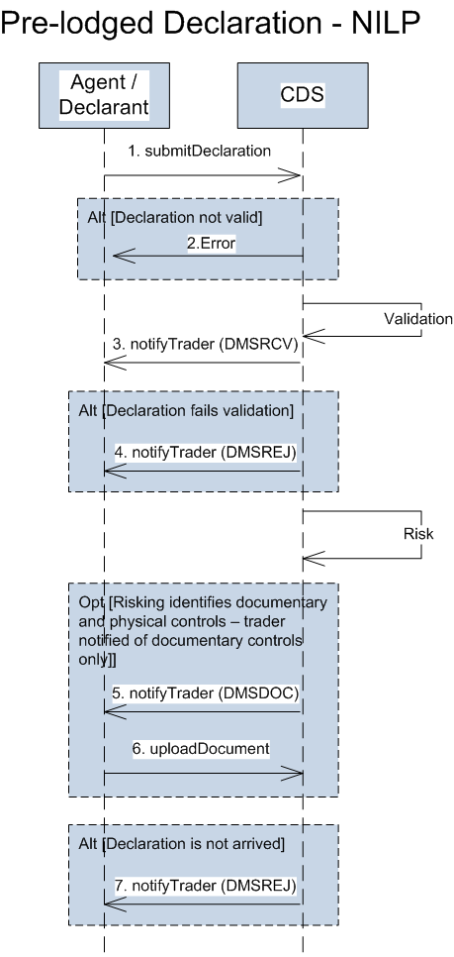

| **ID** | **Operation (endpoint)** | **Description** |
| --- | --- | --- |
| 1 | submitDeclaration  (customs/declarations/submit-declaration) | Submission of the advance/pre-lodged declaration. This could be the full declaration (Type D), the simplified version (Type E or F), or a C21 (Type K) |
| 2 | HTTP error response | Standard error response where the schema does not pass validation at the MDTP level. The mechanism of this error should be defined in the API Schema documentation. |
| 3 | notifyTrader (DMSRCV)  (multiple endpoints using root /notifications) | The submitter is notified of a change in status of the declaration. Following successful validation, this provides the positive response back to the trader that the pre-lodged declaration has been registered. A timer now starts for the goods arrival message to be submitted. If the arrival is not received within 30 days, the declaration is invalidated.  Any credibility checks identified during validation will be passed back here as separate validationResults. |
| 4 | notifyTrader (DMSREJ)  (multiple endpoints using root /notifications) | Operation to notify the submitter that the declaration has failed validation and is rejected. This is an end-state and no further action can be taken on the declaration, nor any further processing within CDS. A new declaration will need to be submitted if the intention is to still import the same goods. |
| 5 | notifyTrader (DMSDOC)  (multiple endpoints using root /notifications) | Operation to notify the submitter of the declaration that a documentary control is required. As this declaration is a pre-lodged declaration then there will be no notification to the trader of any potential physical control. |
| 6 | uploadDocument  (customs/declarations/file-upload) | Following the receipt of the DMSDOC notification, the documentation can be uploaded to the CDS service. |
| 7 | notifyTrader (DMSREJ)  (multiple endpoints using root /notifications) | The specific trader notification regarding the rejection of the declaration following the declaration not being arrived. It will contain a specific error code to indicate the reason for rejection. |

### Arriving a Declaration (NILP)

Please note, the below diagram denotes direct interaction with CDS from an Agent’s software, however, this is only applicable for those declarants that qualify to submit up to 10 declarations a year directly to CDS. Alternatively, or following the 10 declaration limit, the non-inventory linked declarations would go through a CSP. In this case the flow of messages will be the same as below, just with a CSP acting as intermediary for all messages between CDS and the Agent/Declarant.





| **ID** | **Operation (endpoint)** | **Description** |
| --- | --- | --- |
| 1 | importArriveGoods  (customs/declarations/arrival-notification) | Notification from the submitter that the goods have now arrived. Note that this operation can only be used for import goods arrival at a NILP. Export utilises the inventory linking operation. |
| 2 | notifyTrader (DMSREJ)  (multiple endpoints using root /notifications) | If the arrival message fails validation, then CDS will send a DMSREJ notification to inform the declaration submitter of the error. |
| 3 | notifyTrader (DMSRCV)  (multiple endpoints using root /notifications) | If the arrival message passes validation, then CDS will send a DMSRCV notification to inform the declaration submitter of the registration of the additional message. |
| 4 | notifyTrader (DMSREJ)  (multiple endpoints using root /notifications) | The specific trader notification regarding the rejection of the declaration at re-processing. It will contain the specific validation errors that caused the rejection. |
| 5 | notifyTrader (DMSACC)  (multiple endpoints using root /notifications) | The specific trader notification regarding the legal acceptance of the declaration. This effectively sets the tax point.  Any credibility checks identified during validation will be passed back here as separate validationResults. |
| 6 | notifyTrader (DMSDOC)  (multiple endpoints using root /notifications) | Operation to notify the submitter of the identification of a documentary control. This is used to notify the trader of the required control, but also as a request to upload specific documentation. |
| 7 | uploadDocument  (customs/declarations/file-upload) | Following the receipt of the DMSDOC notification, the documentation can be uploaded to the CDS service. |
| 8 | notifyTrader (DMSCTL)  (multiple endpoints using root /notifications) | Potential notification to inform the trader of physical control to be performed against their declaration. |
| 9 | notifyTrader (DMSALV)  (multiple endpoints using root /notifications) | If the declaration was identified as requiring a decision from ALVS (Defra) and the decision was to not release the goods, this message informs the trader of that decision. |
| 10 | notifyTrader (DMSTAX)  (multiple endpoints using root /notifications) | Trader notification providing the debt amounts that have been reserved against their deferment account. This notification can also be used as a prompt for an immediate payment (which will also include a specific payment reference to use). Where the declaration type is simplified, no debt may be liable, depending on the CPC. |
| 11 | notifyTrader (DMSCPI)  (multiple endpoints using root /notifications) | The trader notification regarding the need to take action against a specific account ID. |
| 12 | notifyTrader (DMSCPR)  (multiple endpoints using root /notifications) | Where action has not been taken on a specific account, 24 hours after the DMSCPI is issued, the trader is provided a reminder. Once the reminder has been sent out, and still no action has been taken, further reminders are issued every 24 hours. If no action is taken after 31 days, then a task will be raised to either manually chase the trader, or invalidate the declaration. |
| 13 | notifyTrader (DMSCPR)  (multiple endpoints using root /notifications) | Where action has not been taken to cover an immediate payment, 24 hours after the DMSTAX is issued, the trader is provided a reminder. Once the reminder has been sent out, and still no action has been taken, further reminders are issued every 24 hours. If no action is taken after 31 days, then a task will be raised to either manually chase the trader, or invalidate the declaration. |
| 14 | notifyTrader (DMSRES)  (multiple endpoints using root /notifications) | When an amendment is made on the declaration, then CDS will send out the DMSRES notification describing the amended data elements. |
| 15 | notifyTrader (DMSROG)  (multiple endpoints using root /notifications) | Where the declaration status allows for the goods to be released, but there are still elements that need finalising on the declaration, CDS will inform the trader of ‘release of goods’.  This scenario may occur:   * If the duties calculated are provisional * If there is a non-blocking documentary control open on the declaration * If the declaration type is simplified   Once the declaration has been finalised the clearance notification will be sent. |
| 16 | notifyTrader (DMSRES)  (multiple endpoints using root /notifications) | When an amendment is made on the declaration, then CDS will send out the DMSRES notification describing the amended data elements. |
| 17 | notifyTrader (DMSCLE)  (multiple endpoints using root /notifications) | Following the declaration process, if the control and the debt is finalised the declaration can be cleared. |

### Submitting a Supplementary Declaration (no CSP)

Unlike the above frontier scenarios, there is nothing stopping a declarant submitting a supplementary declaration direct to CDS.



| **ID** | **Operation (endpoint)** | **Description** |
| --- | --- | --- |
| 1 | submitDeclaration  (customs/declarations/submit-declaration) | Submission of a supplementary declaration. This could be one of a Type Y or Z. |
| 2 | notifyTrader (DMSREJ)  (multiple endpoints using root /notifications) | The specific trader notification regarding the rejection of the declaration. It will contain the specific validation errors that caused the rejection. |
| 3 | notifyTrader (DMSACC)  (multiple endpoints using root /notifications) | The specific trader notification regarding the legal acceptance of the declaration. This effectively sets the tax point.  Any credibility checks identified during validation will be passed back here as separate validationResults. |
| 4 | notifyTrader (DMSTAX)  (multiple endpoints using root /notifications) | Trader notification providing the debt amounts that have been reserved against their deferment account. Only deferred methods of payment can be used for supplementary declarations. |
| 5 | notifyTrader (DMSRES)  (multiple endpoints using root /notifications) | When an amendment is made on the declaration, then CDS will send out the DMSRES notification describing the amended data elements. |
| 6 | notifyTrader (DMSROG)  (multiple endpoints using root /notifications) | Where the declaration status allows for the goods to be released, but there are still elements that need finalising on the declaration, CDS will inform the trader of ‘release of goods’.  This scenario may occur:   * If the duties calculated are provisional * If there is a non-blocking documentary control open on the declaration * If the declaration type is simplified   Once the declaration has been finalised the clearance notification will be sent. |
| 7 | notifyTrader (DMSRES)  (multiple endpoints using root /notifications) | When an amendment is made on the declaration, then CDS will send out the DMSRES notification describing the amended data elements. |
| 8 | notifyTrader (DMSCLE)  (multiple endpoints using root /notifications) | Following the declaration process, if the control and the debt is finalised the declaration can be cleared. |

## Export Message Flows

### Submitting a Pre-lodged Declaration (Exports)



| **ID** | **Operation (endpoint)** | **Description** |
| --- | --- | --- |
| 1a | submitDeclaration  (customs/declarations/submit-declaration) | Submission of the advance/pre-lodged declaration. This could be the full declaration (Type D), the simplified version (Type E or F), or a C21 (Type K) |
| 1b |
| 2 | HTTP error response | Standard error response where the schema does not pass validation at the MDTP level. The mechanism of this error should be defined in the API Schema documentation. It is not shown here, but the CSP may pass the error back to the declarant depending on the error. |
| 3a | notifyTrader (DMSREJ)  (multiple endpoints using root /notifications) | Operation to notify the submitter that the declaration has failed validation and is rejected. This is an end-state and no further action can be taken on the declaration, nor any further processing within CDS. A new declaration will need to be submitted if the intention is to still export the same goods. |
| 3b |
| 4a | notifyTrader (DMSRCV)  (multiple endpoints using root /notifications) | The submitter is notified of a change in status of the declaration. Following successful inventory linking and validation, this provides the positive response back to the trader that the pre-lodged declaration has been registered. A timer now starts for the goods arrival message to be submitted. If the arrival is not received within 30 days, the declaration is invalidated.  Any credibility checks identified during validation will be passed back here as separate validationResults. |
| 4b |
| 5a | notifyTrader (DMSDOC)  (multiple endpoints using root /notifications) | Operation to notify the submitter of the declaration that a documentary control is required. As this declaration is a pre-lodged declaration then there will be no notification to the trader of any potential physical control. |
| 5b |
| 6 | uploadDocument  (customs/declarations/file-upload) | Following the receipt of the DMSDOC notification, the documentation can be uploaded to the CDS service. |
| 7 | notifyTrader (DMSREJ)  (multiple endpoints using root /notifications) | The specific trader notification regarding the rejection of the declaration following the declaration not being arrived. It will contain a specific error code to indicate the reason for rejection. |

### Submitting an Arrived Declaration (Exports)



| **ID** | **Operation (endpoint)** | **Description** |
| --- | --- | --- |
| 1a | submitDeclaration  (customs/declarations/submit-declaration) | Submission of an arrived declaration. This could be the full declaration (Type A), the simplified version (Type B or C), or a C21 (Type J) |
| 1b |
| 2a | notifyTrader (DMSREJ)  (multiple endpoints using root /notifications) | The specific trader notification regarding the rejection of the declaration. It will contain the specific validation errors that caused the rejection. |
| 2b |
| 3a | notifyTrader (DMSACC)  (multiple endpoints using root /notifications) | The specific trader notification regarding the legal acceptance of the declaration.  Any credibility checks identified during validation will be passed back here as separate validationResults. |
| 3b |
| 4a | notifyTrader (DMSDOC)  (multiple endpoints using root /notifications) | Operation to notify the submitter of the identification of a documentary control. This is used to notify the trader of the required control, but also as a request to upload specific documentation. |
| 4b |
| 5 | uploadDocument  (customs/declarations/file-upload) | Following the receipt of the DMSDOC notification, the documentation can be uploaded to the CDS service. |
| 6a | notifyTrader (DMSCTL)  (multiple endpoints using root /notifications) | Potential notification to inform the trader of physical control to be performed against their declaration. |
| 6b |
| 7a | notifyTrader (DMSRES)  (multiple endpoints using root /notifications) | When an amendment is made on the declaration, then CDS will send out the DMSRES notification describing the amended data elements. |
| 7b |
| 8a | notifyTrader (DMSROG)  (multiple endpoints using root /notifications) | Where the declaration status allows for the goods to be released, but there are still elements that need finalising on the declaration, CDS will inform the trader of ‘release of goods’.  This scenario may occur:   * If there is a non-blocking documentary control open on the declaration * If the declaration type is simplified   Once the declaration has been finalised the clearance notification will be sent. |
| 8b |
| 9a | notifyTrader (DMSRES)  (multiple endpoints using root /notifications) | When an amendment is made on the declaration, then CDS will send out the DMSRES notification describing the amended data elements. |
| 9b |
| 10a | notifyTrader (DMSCLE)  (multiple endpoints using root /notifications) | Following the declaration process, if the control and the debt is finalised the declaration can be cleared. |

### Submitting a Supplementary Declaration (Exports)



| **ID** | **Operation (endpoint)** | **Description** |
| --- | --- | --- |
| 1a | submitDeclaration  (customs/declarations/submit-declaration) | Submission of a supplementary declaration. This could be one of a Type Y or Z. |
| 1b |
| 2a | notifyTrader (DMSREJ)  (multiple endpoints using root /notifications) | The specific trader notification regarding the rejection of the declaration. It will contain the specific validation errors that caused the rejection. |
| 2b |
| 3a | notifyTrader (DMSACC)  (multiple endpoints using root /notifications) | The specific trader notification regarding the legal acceptance of the declaration.  Any credibility checks identified during validation will be passed back here as separate validationResults. |
| 3b |
| 4a | notifyTrader (DMSRES)  (multiple endpoints using root /notifications) | When an amendment is made on the declaration, then CDS will send out the DMSRES notification describing the amended data elements. |
| 4b |
| 5a | notifyTrader (DMSROG)  (multiple endpoints using root /notifications) | Where the declaration status allows for the goods to be released, but there are still elements that need finalising on the declaration, CDS will inform the trader of ‘release of goods’.  This scenario may occur:   * If there is a non-blocking documentary control open on the declaration * If the declaration type is simplified   Once the declaration has been finalised the clearance notification will be sent. |
| 5b |
| 6a | notifyTrader (DMSRES)  (multiple endpoints using root /notifications) | When an amendment is made on the declaration, then CDS will send out the DMSRES notification describing the amended data elements. |
| 6b |
| 7a | notifyTrader (DMSCLE)  (multiple endpoints using root /notifications) | Following the declaration process, if the control and the debt is finalised the declaration can be cleared. |

### Export Arrival

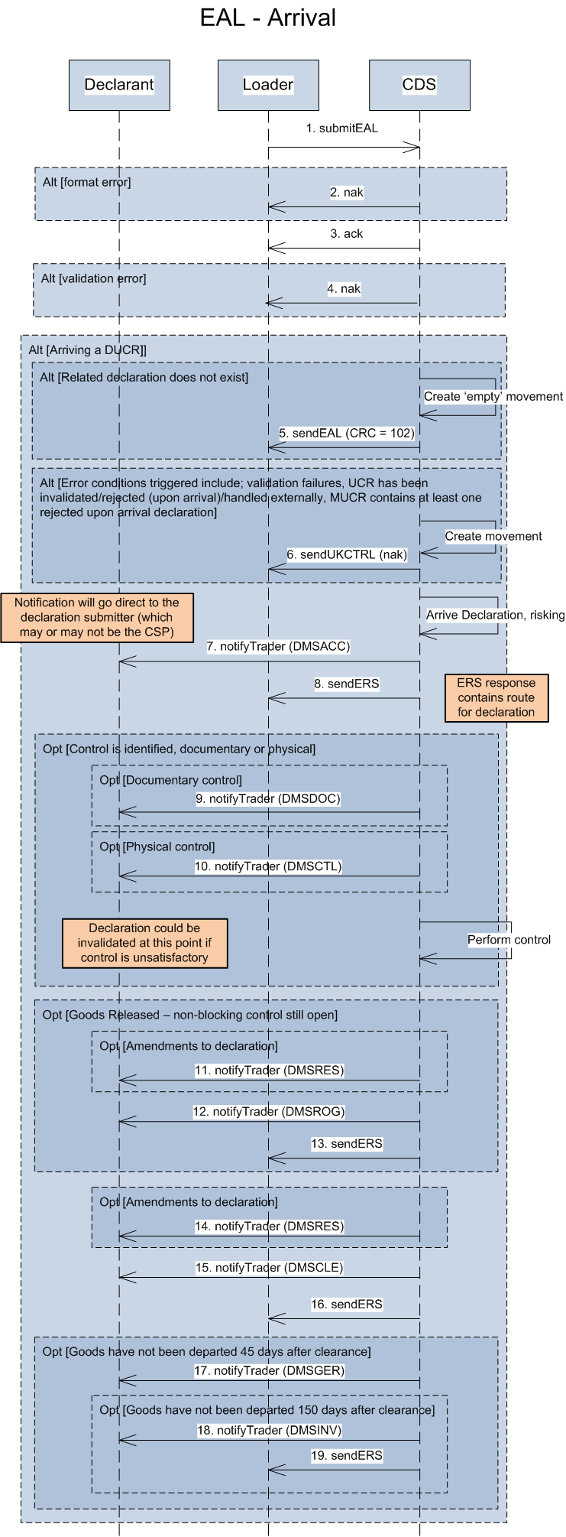

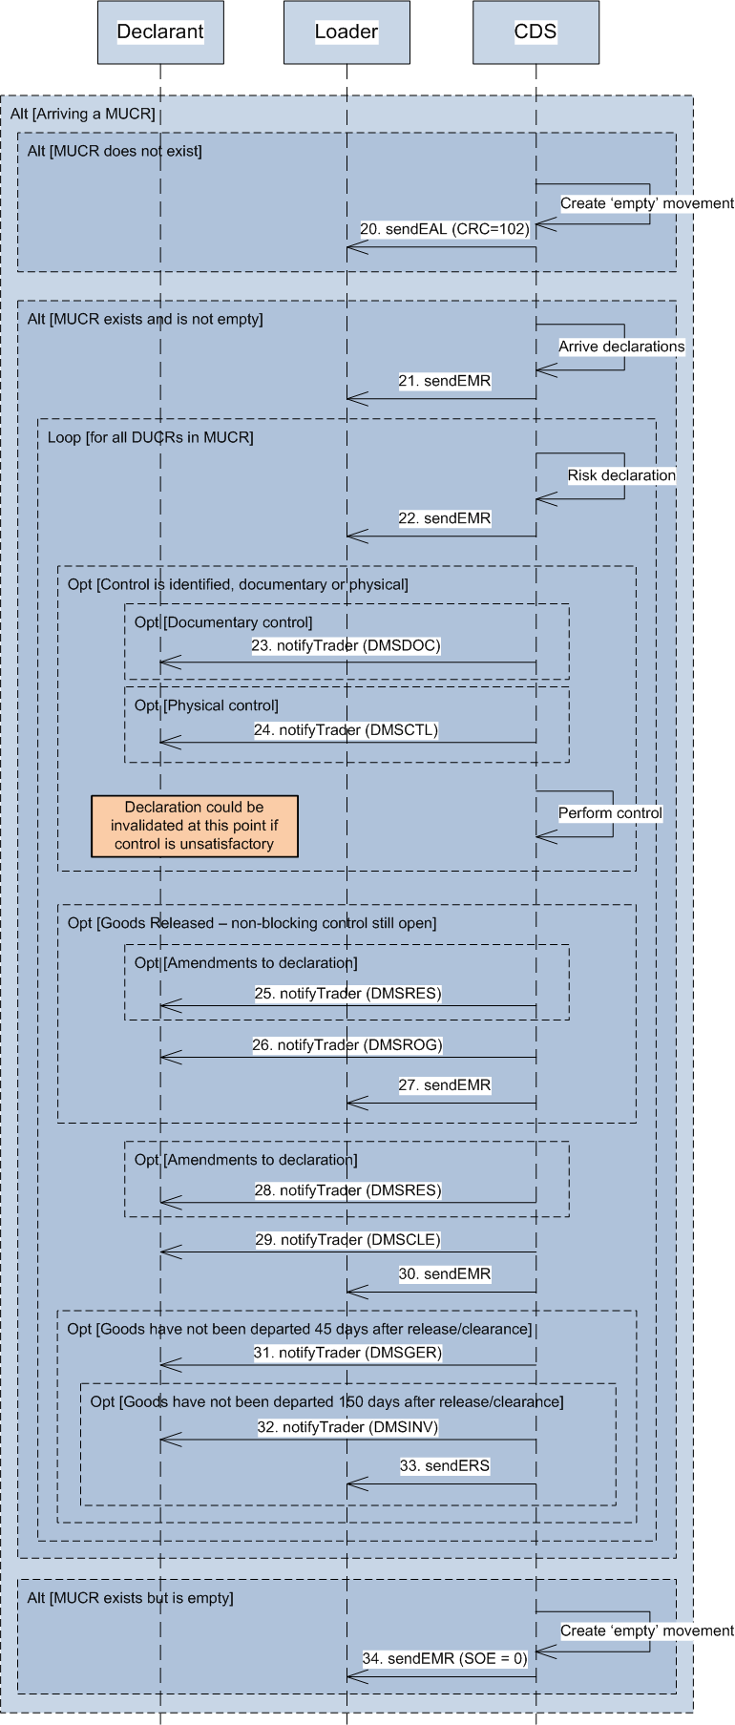

| **ID** | **Operation (endpoint)** | **Description** |
| --- | --- | --- |
| 1 | submitEAL  (customs/inventory-linking/exports) | Loaders will submit an arrival message into CDS, through their CSP or through their own software. Alternatively, an arrival can be submitted through the NESWEB replacement screens. This trigger is the same for inventory linked and non-inventory linked declarations. |
| 2 | nak (Digital) | Where the message fails schema validation, a HTTP error response will be generated. |
| 3 | ack (Digital) | Where the message passes schema validation, a HTTP acceptance response will be generated. |
| 4 | UKCTRL (nak)  (multiple endpoints using root /notifications) | When the message is received by the CDS back end systems, more involved domain validation will occur. Where this fails, a UKCTRL (nak) will be sent back to the submitter of the message. |
| 5 | sendEAL  (multiple endpoints using root /notifications) | If the message is attempting to arrive a DUCR that does not exist, an EAL response will be sent back. The response will contain a CRC value of 102 to indicate this scenario. |
| 6 | UKCTRL (nak)  (multiple endpoints using root /notifications) | During the processing of the arrival, other business validation failures may be identified. This will cause the system to send back a UKCTRL (nak), containing a specific error code to the scenario that caused the failure. |
| 7 | notifyTrader (DMSACC)  (multiple endpoints using root /notifications) | When a declaration is arrived and passes validation, that declaration is legally accepted. A trader notification is generated and passed back through to the declaration submitter. In this diagram it is assumed the declarant submitted the declaration directly to CDS. |
| 8 | sendERS  (multiple endpoints using root /notifications) | Where a declaration has been found, the system will arrive the declaration. Once the risking (or re-risking) has taken place, the an ERS response is formulated which is sent back to the original submitter.  **SOE Code:** The SOE will be 14 (Declaration risked). |
| 9 | notifyTrader (DMSDOC)  (multiple endpoints using root /notifications) | Where a documentary check is identified as required for that declaration, there will be a specific notification to the trader regarding which documents need to be uploaded. |
| 10 | notifyTrader (DMSCTL)  (multiple endpoints using root /notifications) | Where a physical check is identified as required for that declaration, there will be a specific notification to the trader. |
| 11 | notifyTrader (DMSRES)  (multiple endpoints using root /notifications) | When an amendment is made on the declaration, then CDS will send out the DMSRES notification describing the amended data elements. |
| 12 | notifyTrader (DMSROG)  (multiple endpoints using root /notifications) | Following the declaration process, if the control is not finalised the declaration can be released by Customs. Once the control is finalised the declaration is cleared, however this will not be sent to the loader as the goods may already have gone. |
| 13 | sendERS  (multiple endpoints using root /notifications) | A notification is sent to the loader informing them of the decision to release the goods.  **SOE Code:** The SOE will be 2 (Goods released) |
| 14 | notifyTrader (DMSRES)  (multiple endpoints using root /notifications) | When an amendment is made on the declaration, then CDS will send out the DMSRES notification describing the amended data elements. |
| 15 | notifyTrader (DMSCLE)  (multiple endpoints using root /notifications) | Following the declaration process, if the control is finalised the declaration can be cleared by Customs. |
| 16 | sendERS  (multiple endpoints using root /notifications) | A notification is sent to the loader informing them of the decision to release the goods.  **SOE Code:** The SOE will be either 3 (Declaration cleared) if the declaration could be cleared straight away, or 16 (Declaration cleared after goods release) if the goods were released before the declaration was finalised. |
| 17 | notifyTrader (DMSGER)  (multiple endpoints using root /notifications) | If 45 days have passed since the declaration was cleared by Customs, but the goods are still awaiting departure, a notification is sent to the declarant as a reminder. |
| 18 | notifyTrader (DMSINV)  (multiple endpoints using root /notifications) | If 150 days have passed since the declaration was cleared by Customs, but the goods have not yet departed, the declaration is invalidated, and the declarant is notified. |
| 19 | sendERS  (multiple endpoints using root /notifications) | A notification is sent to the loader informing them of the decision to invalidate the declaration.  **SOE Code:** The SOE will be 4 (Declaration invalidation) |
| 20 | sendEAL  (multiple endpoints using root /notifications) | If a MUCR is identified in the EAL message, but can’t be found, an EAL response will be sent back to the originator. The CRC value will be 102. |
| 21 | sendEMR  (multiple endpoints using root /notifications) | Once all DUCR’s within the MUCR have been arrived, an EMR is sent back to the originator with the updated ROE and SOE values for the MUCR. Depending on the Master-Opt value, further details of the individual DUCRs can also be shared.  **SOE Code:** The SOE will be 10 (Declaration accepted at goods arrival). |
| 22 | sendEMR  (multiple endpoints using root /notifications) | Once all DUCR’s within the MUCR are re-risked, and the routes updated, an EMR is sent back to the originator with the updated ROE and SOE values for the MUCR. Depending on the Master-Opt value, further details of the individual DUCRs can also be shared.  **SOE Code:** The SOE will be 14 (Declaration risked). |
| 23 | notifyTrader (DMSDOC)  (multiple endpoints using root /notifications) | Where a documentary check is identified as required for that declaration, there will be a specific notification to the trader regarding which documents need to be uploaded. |
| 24 | notifyTrader (DMSCTL) | Where a physical check is identified as required for that declaration, there will be a specific notification to the trader. |
| 25 | notifyTrader (DMSRES)  (multiple endpoints using root /notifications) | When an amendment is made on the declaration, then CDS will send out the DMSRES notification describing the amended data elements. |
| 26 | notifyTrader (DMSROG)  (multiple endpoints using root /notifications) | Once the declarations have passed validation and have satisfactory control results, the MUCR status will be updated to released or cleared. Released is used where there are outstanding non-blocking control tasks. |
| 27 | sendEMR  (multiple endpoints using root /notifications) | Where there are outstanding non-blocking control tasks, this change in status will trigger the additional EMR to the originator of the request.  **SOE Code:** The SOE will be 2 (Goods released) |
| 28 | notifyTrader (DMSRES)  (multiple endpoints using root /notifications) | When an amendment is made on the declaration, then CDS will send out the DMSRES notification describing the amended data elements. |
| 29 | notifyTrader (DMSCLE)  (multiple endpoints using root /notifications) | Once the declarations have passed validation and have satisfactory control results, the MUCR status will be updated to released or cleared. |
| 30 | sendEMR  (multiple endpoints using root /notifications) | Once control is completed and the underlying declarations are cleared, the Master SOE of the MUCR will change to show that clearance can be provided. This change in status will trigger the additional EMR to the originator of the request.  **SOE Code:** The SOE will be either 3 (Declaration cleared) if the declaration could be cleared straight away, or 16 (Declaration cleared after goods release) if the goods were released before the declaration was finalised. |
| 31 | notifyTrader (DMSGER)  (multiple endpoints using root /notifications) | If 45 days have passed since the declaration was cleared by Customs, but the goods are still awaiting departure, a notification is sent to the declarant as a reminder. |
| 32 | notifyTrader (DMSINV)  (multiple endpoints using root /notifications) | If 150 days have passed since the declaration was cleared by Customs, but the goods have not yet departed, the declaration is invalidated, and the declarant is notified. |
| 33 | sendERS  (multiple endpoints using root /notifications) | A notification is sent to the loader informing them of the decision to invalidate the declaration.  **SOE Code:** The SOE will be 4 (Declaration invalidated). |
| 34 | sendEMR  (multiple endpoints using root /notifications) | Where a MUCR is not yet shut, it will always have an SOE value of ‘0’, regardless of the status of the underlying declarations. |

### Export Anticipated Arrival

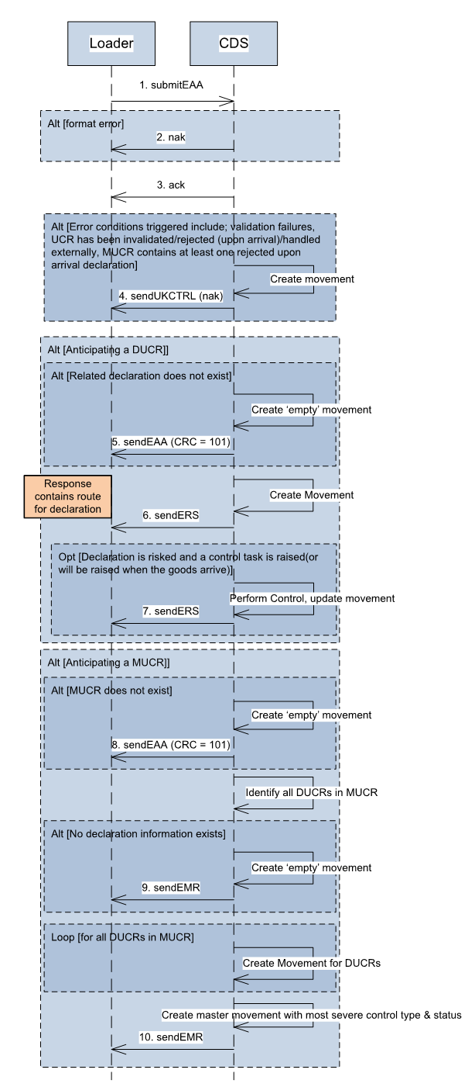

| **ID** | **Operation (endpoint)** | **Description** |
| --- | --- | --- |
| 1 | submitEAA  (customs/inventory-linking/exports) | Loaders will submit an anticipated arrival message into CDS, through their CSP or through their own software. Alternatively, it can be submitted through the NESWEB replacement screens. |
| 2 | nak (Digital) | Where the message fails schema validation, a HTTP error response will be generated. |
| 3 | ack (Digital) | Where the message passes schema validation, a HTTP acceptance response will be generated. |
| 4 | UKCTRL (nak)  (multiple endpoints using root /notifications) | During the processing of the message, business validation failures may be identified. This will cause the system to send back a UKCTRL (nak), containing a specific error code to the scenario that caused the failure. |
| 5 | sendEAA  (multiple endpoints using root /notifications) | If the message is attempting to anticipate a DUCR that does not exist, an EAA response will be sent back. The response will contain a CRC value of 101 to indicate this scenario. |
| 6 | sendERS  (multiple endpoints using root /notifications) | Where a pre-lodged declaration has been found, the system will send an ERS response formulated from the initial risking of the data.  **SOE Code:** The SOE will be 14 (Declaration risked). |
| 7 | sendERS  (multiple endpoints using root /notifications) | Any update to the declaration data will trigger an ERS. In reality, for the majority of cases, only one ERS will be sent. This is due to the fact that for the majority of pre-lodged declarations, once risking has completed, the declaration will not change state until it is arrived.  **SOE Code:** The SOE will be 14 (Declaration risked). |
| 8 | sendEAA  (multiple endpoints using root /notifications) | Alterntively, if a MUCR is identified in the EAA message, but can’t be found, an EAA response will be sent back to the originator. The CRC value will be 101. |
| 9 | sendEMR  (multiple endpoints using root /notifications) | Where a MUCR is found that contains pre-lodged declarations, a response will be sent back to the originator with a master value for route and status based on the underlying declaration data. |
| 10 | sendEMR  (multiple endpoints using root /notifications) | Where a MUCR is not yet shut, it will always have an SOE value of ‘0’, regardless of the status of the underlying declarations. |

### Export Departure



| **ID** | **Operation (endpoint)** | **Description** |
| --- | --- | --- |
| 1 | submitEDL  (customs/inventory-linking/exports) | Loaders will submit a departure message into CDS, through their CSP or through their own software. Alternatively, it can be submitted through the NESWEB replacement screens. |
| 2 | nak (Digital) | Where the message fails schema validation, a HTTP error response will be generated. |
| 3 | ack (Digital) | Where the message passes schema validation, a HTTP acceptance response will be generated. |
| 4 | UKCTRL (nak)  (multiple endpoints using root /notifications) | During the processing of the message, other business validation failures may be identified. This will cause the system to send back a UKCTRL (nak), containing a specific error code to the scenario that caused the failure. |
| 5 | UKCTRL (ack)  (multiple endpoints using root /notifications) | Once the movement has been recorded as departed within CDS, the originator will receive a positive confirmation through a UKCTRL. |
| 6a | notifyTrader (DMSEOG)  (multiple endpoints using root /notifications) | Once the exit message has been recorded within CDS, a separate notification will be sent to the submitter of the declaration. This is to notify the trader that their goods have exited from the Customs Union. |
| 6b |
| 7 | UKCTRL (nak)  (multiple endpoints using root /notifications) | During the processing of the message, other business validation failures may be identified. This will cause the system to send back a UKCTRL (nak), containing a specific error code to the scenario that caused the failure. |
| 8 | UKCTRL (ack)  (multiple endpoints using root /notifications) | Once the movement has been recorded as departed within CDS, the originator will receive a positive confirmation through a UKCTRL. |
| 9a | notifyTrader (DMSEOG)  (multiple endpoints using root /notifications) | When a MUCR is departed, CDS will determine all the underlying declarations that are contained within it. All the declarations that are cleared, or released, will then be recorded as exited. Once the exit has been recorded within CDS, a separate notification will be sent to the submitter of the declaration. This is to notify the trader that their goods have exited from the Customs Union. This is repeated for each declaration. |
| 9b |

### Consolidation Association

#### Loader Association



#### Declarant Association



| **ID** | **Operation (endpoint)** | **Description** |
| --- | --- | --- |
| 1 | submitEAC  (customs/inventory-linking/exports) | An association request is submitted to CDS, either through the API or the UI. The fact an association is requested is derived from the presence of both the MUCR and child UCR references. |
| 2 | nak (Digital) | Where the message fails schema validation, a HTTP error response will be generated. |
| 3 | ack (Digital) | Where the message passes schema validation, a HTTP acceptance response will be generated. |
| 4 | UKCTRL (nak)  (multiple endpoints using root /notifications) | When the message is received by the CDS back end systems, more involved domain validation will occur. Where this fails, a UKCTRL (nak) will be sent back to the submitter of the message. |
| 5 | UKCTRL (ack)  (multiple endpoints using root /notifications) | Once the association has been processed within CDS, the originator will receive a positive confirmation through a UKCTRL. |
| 6 | sendEMR  (multiple endpoints using root /notifications) | Once an association is complete, the Master SOE and ROE are re-assessed. Regardless of whether the values changed, an EMR is sent to the submitter of the last movement request (if one exists). |

### Consolidation Disassociation

#### Loader Disassociation



#### Declarant Disassociation



| **ID** | **Operation (endpoint)** | **Description** |
| --- | --- | --- |
| 1 | submitEAC  (customs/inventory-linking/exports) | A disassociation request is submitted to CDS, either through the API or the UI. The fact a disassociation is requested is derived from the presence of just the child UCR reference. |
| 2 | nak (Digital) | Where the message fails schema validation, a HTTP error response will be generated. |
| 3 | ack (Digital) | Where the message passes schema validation, a HTTP acceptance response will be generated. |
| 4 | UKCTRL (nak)  (multiple endpoints using root /notifications) | When the message is received by the CDS back end systems, more involved domain validation will occur. Where this fails, a UKCTRL (nak) will be sent back to the submitter of the message. |
| 5 | UKCTRL (ack)  (multiple endpoints using root /notifications) | If the disassociation was requested through an EAC transaction (as opposed to a declaration invalidation), once the disassociation has been processed within CDS, the originator will receive a positive confirmation through a UKCTRL. |
| 6 | sendEMR  (multiple endpoints using root /notifications) | Once an disassociation is complete, the Master SOE and ROE are re-assessed. Regardless of whether the values changed, an EMR is sent to the submitter of the last movement request (if one exists). |

### Consolidation Shut

#### Loader Shut



#### Declarant Shut



| **ID** | **Operation (endpoint)** | **Description** |
| --- | --- | --- |
| 1 | submitCST  (customs/inventory-linking/exports) | A shut request is submitted to CDS, either through the API or the UI. The fact a shut is requested is derived from either the transaction type (CST), or if EAC is used, the presence of just the Parent UCR reference. |
| 2 | nak (Digital) | Where the message fails schema validation, a HTTP error response will be generated. |
| 3 | ack (Digital) | Where the message passes schema validation, a HTTP acceptance response will be generated. |
| 4 | UKCTRL (nak)  (multiple endpoints using root /notifications) | When the message is received by the CDS back end systems, more involved domain validation will occur. Where this fails, a UKCTRL (nak) will be sent back to the submitter of the message. |
| 5 | UKCTRL (ack)  (multiple endpoints using root /notifications) | Once the shut has been processed within CDS, the originator will receive a positive confirmation through a UKCTRL. |
| 6 | sendEMR  (multiple endpoints using root /notifications) | Once an shut is complete, the Master SOE and ROE are re-assessed. Regardless of whether the values changed, an EMR is sent to the submitter of the last movement request (if one exists). |

### Re-arrival of a UCR



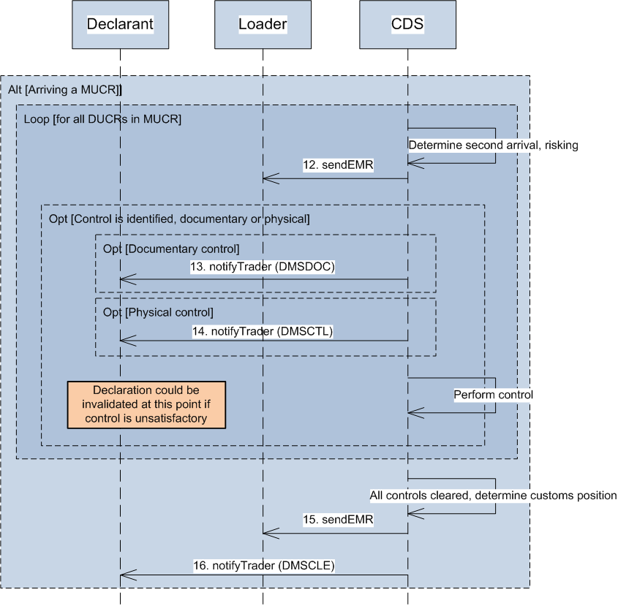

| **ID** | **Operation (endpoint)** | **Description** |
| --- | --- | --- |
| 1 | submitEAL  (customs/inventory-linking/exports) | Loaders will submit an arrival message into CDS, through their CSP or through their own software. Alternatively, an arrival can be submitted through the NESWEB replacement screens. |
| 2 | nak | Where the message fails schema validation, a HTTP error response will be generated. |
| 3 | ack | Where the message passes schema validation, a HTTP acceptance response will be generated. |
| 4 | nak | When the message is received by the CDS back end systems, more involved domain validation will occur. Where this fails, a UKCTRL (nak) will be sent back to the submitter of the message. |
| 5 | sendUKCTRL (nak)  (multiple endpoints using root /notifications) | During the processing of the arrival, other business validation failures may be identified. This will cause the system to send back a UKCTRL (nak), containing a specific error code to the scenario that caused the failure. See the Inventory Linking Export Service design for a full list of error codes. |
| 6 | notifyTrader (DMSRCV)  (multiple endpoints using root /notifications) | Where the arrival message is valid, and DMSRCV is sent back to the originating submitter of the declaration to notify them of the re-arrival. Note that this is different to an actual arrival where a DMSACC would be sent back. |
| 7 | sendERS  (multiple endpoints using root /notifications) | Where a declaration has been found, the system will re-arrive the declaration. Once the re-risking has taken place, the an ERS response is formulated which is sent back to the original submitter of the movement message. |
| 8 | notifyTrader (DMSDOC)  (multiple endpoints using root /notifications) | Where a documentary check is identified as required for that declaration, there will be a specific notification to the trader regarding which documents need to be uploaded. |
| 9 | notifyTrader (DMSCTL)  (multiple endpoints using root /notifications) | Where a physical check is identified as required for that declaration, there will be a specific notification to the trader. |
| 10 | notifyTrader (DMSCLE)  (multiple endpoints using root /notifications) | Following the risking process, if the control is finalised the movement can be cleared by Customs. |
| 11 | sendERS  (multiple endpoints using root /notifications) | A notification is sent to the loader informing them of the decision to release the goods. |
| 12 | sendEMR  (multiple endpoints using root /notifications) | Once all DUCR’s within the MUCR are re-risked, and the routes updated, an EMR is sent back to the originator with the updated ROE and SOE values for the MUCR. Depending on the Master-Opt value, further details of the individual DUCRs can also be shared. |
| 13 | notifyTrader (DMSDOC)  (multiple endpoints using root /notifications) | Where a documentary check is identified as required for that declaration, there will be a specific notification to the trader regarding which documents need to be uploaded. |
| 14 | notifyTrader (DMSCTL)  (multiple endpoints using root /notifications) | Where a physical check is identified as required for that declaration, there will be a specific notification to the trader. |
| 15 | sendEMR  (multiple endpoints using root /notifications) | Once control is completed and the underlying declarations are cleared, the Master SOE of the MUCR will change to show that clearance can be provided. This change in status will trigger the additional EMR to the originator of the request. |
| 16 | notifyTrader (DMSCLE)  (multiple endpoints using root /notifications) | Once the movements have satisfactory control results, the MUCR status will be updated to cleared. Each declarant related to the MUCR will be notified of the clearance. |

### Re-processing of a Declaration



| **ID** | **Operation (endpoint)** | **Description** |
| --- | --- | --- |
| 1 | submitDeclaration  (customs/declarations/submit-declaration) | A prelodged declaration is submitted and validated. MUCR/DUCR validation checks that the consolidation is open or non-existent, and that the DUCR is unique. |
| 2 | notifyTrader (DMSRCV)  (multiple endpoints using root /notifications) | The validation is passed, so a DMSRCV notification is sent back to the originating submitter. In this case, assumed that the declarant submitted directly to CDS. |
| 3 | submitEAL  (customs/inventory-linking/exports) | Once the goods arrive, the loader submits an EAL message to CDS. |
| 4 | sendERS/EMR  (multiple endpoints using root /notifications) | The declaration is re-validated. However, in this scenario since the pre-lodgement, the validation rules have changed. This now causes the declaration to be rejected. The response is sent back to the loader notifying them of the ‘rejection at arrival’.  CDS updates the status of the consignment. It is now only allowed to be dis-associated. |
| 5 | notifyTrader (DMSREJ)  (multiple endpoints using root /notifications) | The trader is notified of the rejection of the declaration following the arrival. |
| 6 | submitDeclaration  (customs/declarations/submit-declaration) | The pre-lodged declaration is then re-submitted. This will contain the same DUCR as the previous declaration. Due to the status of the DUCR being in a state of ‘rejected at arrival’, the declaration is allowed to be processed with a shut MUCR and a non-unique DUCR. |
| 7 | notifyTrader (DMSRCV)  (multiple endpoints using root /notifications) | The declaration passes the validation and a DMSRCV is sent to the declarant. |
| 8 | notifyTrader (DMSACC)  (multiple endpoints using root /notifications) | The declaration is automatically arrived due to the presence of an existing EAL within CDS. This causes a DMSACC to be sent to the trader. |
| 9 | sendERS/EMR  (multiple endpoints using root /notifications) | Following the risking of the arrived declaration, the loader is notified of the updated status and route of the DUCR/MUCR. It is no longer held at ‘rejected at arrival’. |

## Additional Message & Miscellaneous Flows

### Declaration Amendment

#### Imports



| **ID** | **Operation (endpoint)** | **Description** |
| --- | --- | --- |
| 1a | submitAmendment  (customs/declarations/amendment-request) | The declarant submits an amendment through to CDS via the digital API. For inventory linking import declarations, this needs to go via the CSP. |
| 1b |
| 2 | inventoryLinkingImportValidateMovementRequest  (multiple endpoints using root /notifications) | During the declaration re-validation the linking is re-checked.  **ICS/ROE Values:**The request will have an ICS value of '7' (Amendment Validation) and an ROE value of '0' (control yet to be performed). |
| 3 | inventoryLinkingImportValidateMovementResponse  (customs/inventory-linking-imports/movement-validation) | The response back to the CDS service which comprises of the schema as defined. The key value will be the IRC which specifies whether the match has been successful. An unsuccessful match is the trigger for the re-validation loop as specified in the Inventory Linking Import specification. |
| 4a | notifyTrader (DMSREJ)  (multiple endpoints using root /notifications) | Operation to notify the submitter that the additional message has failed validation and is rejected. Processing will now be paused on the existing declaration and will resume when a valid amendment is submitted. |
| 4b |
| 5a | notifyTrader (DMSRCV)  (multiple endpoints using root /notifications) | The amendment has passed validation and the process will now assess the declaration state to determine if it can be applied. The request may be passed to a Customs Officer to make a manual determination. |
| 5b |
| 6a | notifyTrader (DMSREQ)  (multiple endpoints using root /notifications) | If the amendement is accepted then a DMSREQ is sent back to the submitter of the message. The NameCode field states whether the decision was grant or deny. |
| 6b |
| 7a | notifyTrader (DMSREQ)  (multiple endpoints using root /notifications) | If the amendement is refused then a DMSREQ is sent back to the submitter of the message. The NameCode field states whether the decision was grant or deny. |
| 7b |

#### Exports



| **ID** | **Operation** | **Description** |
| --- | --- | --- |
| 1a | submitAmendment  (customs/declarations/amendment-request) | The declarant submits an amendment through to CDS via the digital API. For inventory linking import declarations, this needs to go via the CSP. |
| 1b |
| 2a | notifyTrader (DMSREJ)  (multiple endpoints using root /notifications) | Operation to notify the submitter that the additional message has failed validation and is rejected. Processing will now be paused on the existing declaration and will resume when a valid amendment is submitted. |
| 2b |
| 3a | notifyTrader (DMSRCV)  (multiple endpoints using root /notifications) | The amendment has passed validation and the process will now assess the declaration state to determine if it can be applied. The request may be passed to a Customs Officer to make a manual determination. |
| 3b |
| 4a | notifyTrader (DMSREQ)  (multiple endpoints using root /notifications) | If the amendment is accepted then a DMSREQ is sent back to the submitter of the message. The NameCode field states whether the decision was grant or deny. |
| 4b |
| 5a | notifyTrader (DMSREQ)  (multiple endpoints using root /notifications) | If the amendement is refused then a DMSREQ is sent back to the submitter of the message. The NameCode field states whether the decision was grant or deny. |
| 5b |

### Declaration Invalidation

This flow shows the trader initiating a cancellation. If Customs decides to cancel a declaration, the process would effectively start from Step 6. Details of the invalidation message can be found in the Customs Declaration API document [1].

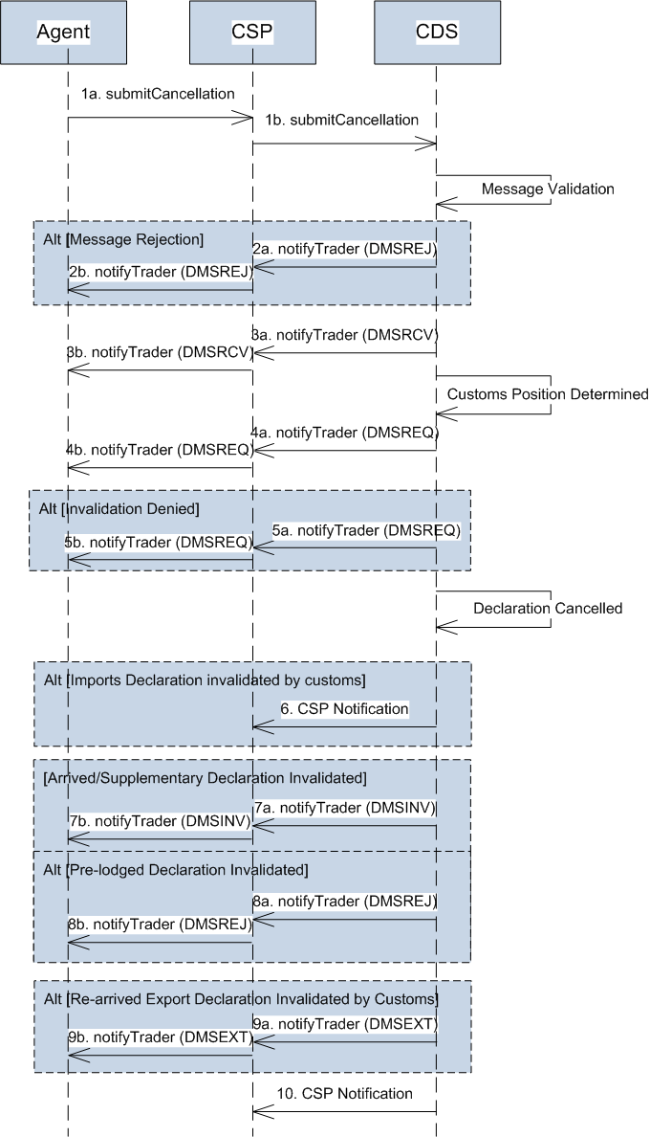

| **ID** | **Operation (endpoint)** | **Description** |
| --- | --- | --- |
| 1a | submitInvalidationRequest  (customs/declarations/cancellation-requests) | Submission of the invalidation request from the trader. This will include declaration identifiers along with the reason for cancellation. |
| 1b |
| 2a | notifyTrader (DMSREJ)  (multiple endpoints using root /notifications) | Operation to notify the submitter that the additional message has failed validation and is rejected. No action is taken on the declaration. |
| 2b |
| 3a | notifyTrader (DMSRCV)  (multiple endpoints using root /notifications) | The invalidation request has passed validation and the process will now assess the declaration state to determine if it can be invalidated. The request may be passed to a Customs Office to make a manual determination. |
| 3b |
| 4a | notifyTrader (DMSREQ)  (multiple endpoints using root /notifications) | If the request for cancellation is accepted then a DMSREQ is sent back to the submitter of the declaration (N.B. same notification type as above). The NameCode field states whether the decision was grant or deny. |
| 4b |
| 5a | notifyTrader (DMSREQ)  (multiple endpoints using root /notifications) | If the request for cancellation is refused then a DMSREQ is sent back to the submitter of the declaration. The NameCode field states whether the decision was grant or deny. |
| 5b |
| 6 | CSP Notification (Imports)  (multiple endpoints using root /notifications) | If the declaration has been invalidated by customs as a result of failing control, the CSP (if Inventory Linked) will be notified of the customs position.  The declaration status (ICS) will be 15 (Customs Position Determined). |
| 7a | notifyTrader (DMSINV)  (multiple endpoints using root /notifications) | Once the declaration is cancelled, a notification is sent back to the submitter confirming the action. |
| 7b |
| 8a | notifyTrader (DMSREJ)  (multiple endpoints using root /notifications) | When a pre-lodged declaration is cancelled, a DMSREJ is generated instead of a DMSINV as the declaration is not yet legally accepted. |
| 8b |
| 9a | notifyTrader (DMSEXT)  (multiple endpoints using root /notifications) | When an export declaration is re-arrived, but then seized at that location, then the declaration moves into a handle externally state. |
| 9b |
| 10 | CSP Notification (Imports and Exports)  (multiple endpoints using root /notifications) | Following the cancellation of the declaration (if Inventory Linked), the CSP will be notified of the declaration cancellation.  **ICS/ROE Values:** The declaration status (ICS for Imports/SOE for Exports) will be 4 (Invalidation) for a legally accepted declaration and 11 (Rejected at Arrival) for a pre-lodged. Where an exports declaration has been cancelled at the trader’s request, the ICS value will be 3, and if it was cancelled by Customs or Border Force, the ICS value will be 6. Where a re-arrived declaration is seized, the SOE value will be ‘6’. ROE will be based on the control type. |

# Appendices

## Declaration Types

The following table lists the possible Declaration Types and their description, as well as whether these are frontier or pre-lodged declarations and whether they can be inventory-linked:

| **Type** | **Description** |
| --- | --- |
| A | Standard customs declaration (frontier). Can be inventory-linked. |
| B | Simplified declaration on an occasional basis (frontier). Can be inventory-linked. |
| C | Simplified declaration with regular use, pre-authorised (frontier). Can be inventory-linked. |
| D | Standard customs declaration (pre-lodged). Can be inventory-linked. |
| E | Simplified declaration on an occasional basis (pre-lodged). Can be inventory-linked. |
| F | Simplified declaration with regular use, pre-authorised (pre-lodged). Can be inventory-linked. |
| J | C21 customs clearance request (frontier). Can be inventory-linked. |
| K | C21 customs clearance request (pre-lodged). Can be inventory-linked. |
| Y | Supplementary declaration covered by types C and F |
| Z | Supplementary declaration (entry into declarant’s records) |

# Document Control

**Status:**

|  |  |
| --- | --- |
| **Author** | Ben Wallis |
| **Status** | Issued |

Change Log:

| Version | Date | Author | Comments *(please include names of approvers in this section)* |
| --- | --- | --- | --- |
| V1.0 | 16.03.18 | BW | First release for internal review |
| V1.1 | 04.04.18 | BW | Updated following internal review |
| V1.2 | 05.04.18 | BW | Version for external release |
| V1.3 | 19.04.18 | BW | Updated following trade feedback – additional section added describing which transactions are CSP-only. |
| V2.0 | 24.04.18 | BW | Tracked changes removed. |
| V2.1 | 30.05.18 | BW | Updated with a new diagram for supplementary declaration submission where a CSP is not used as a message broker. |
| V2.2 | 04.07.18 | BW | Updated the text under the non-CSP sequence diagrams to make clear these are only appropriate in certain circumstances. |
| V2.3 | 06.07.18 | LP | Tracked changes removed. |
| V2.4 | 26.07.18 | AG | Added section 2.1.2 Key Identifiers for Messages |
| V2.5 | 26.07.18 | BW | Updated the document to include the invalidation sequence. |
| V2.6 | 13.08.18 | BW | Updated with the Inventory Linking transaction flows. |
| V3.0 | 31.08.18 | BW | Finalised following internal review |
| V3.1 | 05.10.18 | BW | Minor heading changes |
| V3.2 | 30.10.18 | BW | Updated following CSP feedback on Export sequence diagrams |
| V3.3 | 06.11.18 | BW | Minor changes following internal review |
| V3.4 | 11.01.18 | BW | Updates to include DMSRES notification into DMSROG and CLE |
| V3.5 | 26.02.19 | SP | Minor updates |
| V3.6 | 20.03.19 | BW | Updated to reflect the deconsolidation of all notifications (RES, ROG and CLE split) |
| V3.7 | 09.04.19 | SP | Tracked changes removed |
| V4.0 | 09.04.19 | SP | Baselined for issue |
| V4.2 | 06.06.19 | BW | Updated for amendments and pre-lodged cancellations |
| V4.3 | 05.08.19 | BW | Corrected the EAA and EAL responses where no UCR is found. |
| V4.4 | 14.08.19 | BW | Updated with Re-arrival and Re-processing sequence diagrams |
| V4.5 | 16.09.19 | BW | Updated with endpoints per request |
| V4.6 | 7.10.19 | BW | Updated CRC 101/102 responses with correct message response. Updated invalidation flow to show DMSINV is alternate. |
| V4.7 | 20.12.19 | NA | Updated Export Arrival flow to describe behaviour when goods are cleared but not departed. Updated Declaration Invalidation flow with extra CSP notification when invalidated by Customs. |
| V4.8 | 16.01.20 | NA | Clarified that ICS 17 represents an issue with an account-based MOP and the timings associated with DMSCPI, DMSCPR, and rejection following non-arrival. |
| V4.9 | 24.01.20 | NA | Removed mention of Master SOE being sent before clearance had fully been issued in step 27 of export arrival flow. |
| V5.0 | 01.04.20 | JS/NA | Added exports flows for pre-lodged, arrived and supplementary declarations. Expanded on control notifications in imports flows. Added table of declaration types. Removed references to internal inventory linking logic. Clarified various minor queries in flows. |
| V5.1 | 02.04.20 | JS | Specifically mentioned types J and K in declaration flows. Added SOE codes for messages in 2.3.4, 2.3.5, 2.3.6 |

OFFICIAL

© HM Revenue & Customs 2020.

All rights reserved.